Hello lovely musicians.

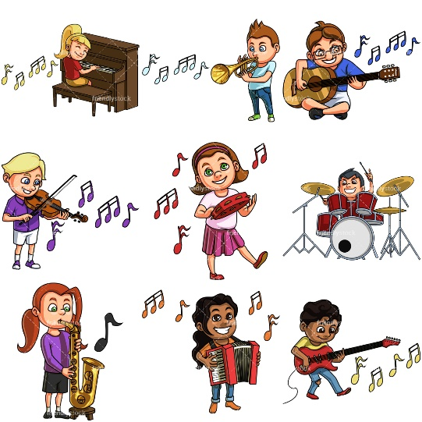
I do hope you’ve been making some lovely music. I’ve been doing lots
of singing and playing the piano and violin. I do hope you’ve been
playing any instruments you have. I know lots of you are very
good at playing the piano, violin, guitar, ukulele or recorder.
Perhaps someone at home could help you learn something.
Also, there is lots of help online.

I’ve recorded a couple of songs for you to sing along with while you’re at home.
SONG 1
‘Build it high’ is a song that Puffins have been learning so Puffins, you will already know it quite well. Perhaps you could teach it to someone in your family and can you learn ALL the words??
For everyone else, it is a feel-good song about trying hard and not giving up. Great fun to sing.
SONG 2
‘New Beginning’ is a song about the Spring which is now and how wonderful it is. I’m sure you have noticed plants growing and birds singing really loudly! I have recorded it in sections to help you learn it and then all the way through at the end for you to have a big performance.

You’ll find the words here too.

Happy Singing & playing.

Mrs England
Build It High by Suzy Davies
Chorus
We’ve got a problem, we can work it out.
Let’s get together, that’s what it’s all about.
Got to build it, build it high.
Got to build it, build it high. (repeat)

Verse 1
Don’t give in because you fail your first attempt.
Don’t start shouting, what’s the point in argument?
Let’s stand united, take the challenge in our stride.
Just remember that we’re on the same side

Chorus
We’ve got a problem, we can work it out.
Let’s get together, that’s what it’s all about.
Got to build it, build it high.
Got to build it, build it high.

Verse 2
Don’t start blaming someone else when things go wrong.
That’s wasting precious time and we don’t have too long.
No use in panic….when the situation’s grim.
Trust in team work and let the game begin!

Chorus
We’ve got a problem, we can work it out.
Let’s get together, that’s what it’s all about.
Got to build it, build it high.
Got to build it, build it high, build it high, build it high, build it high.
New Beginning by Emily Barden

Verse 1
Say goodbye to colder days, the sky begins to clear.
Give a wave to Winter for a year.
Like the clocks, we all leap forward,
Hop, skip, jump and play.
Spring is here, it’s time for us to say.

Chorus
Flowers are growing and the birds are singing,
Welcome in this new beginning.
Spring has sprung and we’ve begun to see the gifts that Nature’s bringing.
Warm days are coming, all the earth is singing,
Welcome in this new beginning.
Spring is here so give a cheer for all the gifts that Nature’s bringing.

Verse 2
Underneath the frozen ground, plants were just asleep.
As the sun shines, shoots will start to peep.
The world that seemed so dull and cold has come alive once more.
Begin again, it’s what the springtime’s for.

