Puffins class daily schedule

Please remember to try and log in to Reflex and Spelling shed every day!

Reading: (about 10 - 20 mins)

Have a look at the Oxford Owl series - https://www.oxfordowl.co.uk/for-home/find-a-book/library-page?view=image&query=&type=book&age_group=Age+5-6&level=&level_select=&book_type=&series=#
Choose a book from here to read. You do have to register but the books should be free to read.

Continue to read for at least 10 minutes every day and talk to an adult about any words that you don’t know. Add any new words to your new vocabulary list. Check out https://alverton.eschools.co.uk/website/reading_resources/462727 for lots of ideas!

Or borrow a book from school - you can phone reception to make an appointment and come in to borrow a reading book from us.

Or see the resources here - https://alverton.eschools.co.uk/website/reading_resources/462727

Phonics & Spelling: (about 10 min)

This is the website we will be using: Phonics play Login: march20 Password: home

This is the website we will be using: Phonics play Login: march20 Password: home
https://www.phonicsplay.co.uk/resources/phase/5

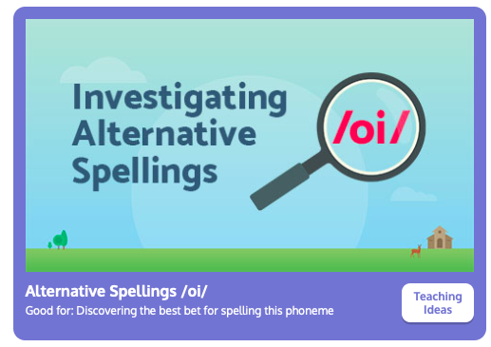
We will be practising alternative spellings this week, oi today.

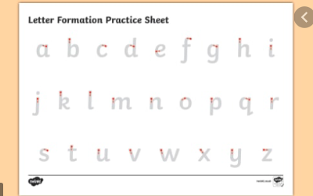
Handwriting
Make sure anything you write is correctly formed. There needs to be a difference between the heights of the letters.

English: (about 20 - 30 min)

Today we are going to use our plans from Wednesday to help us write a postcard. You have already done the hard work, now we need to put it together.

Read this example below and see if you can spot the postcard writing skills?
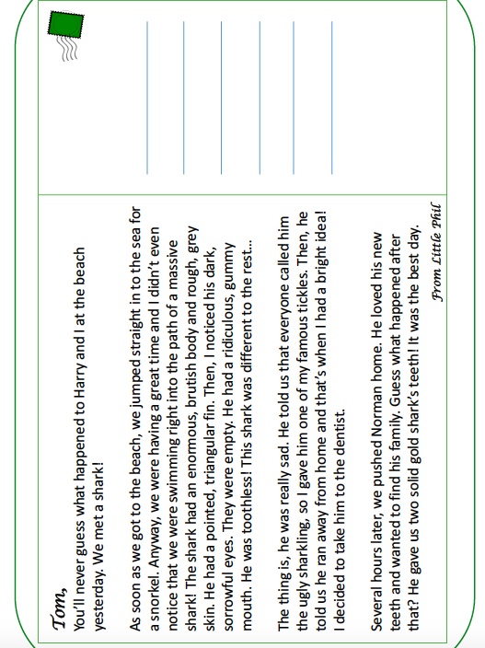
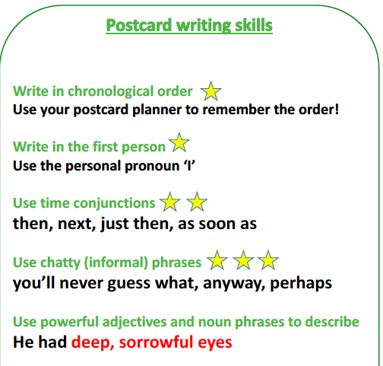

Now you are ready!

Use the blank postcard below to write a postcard from Little Phil.

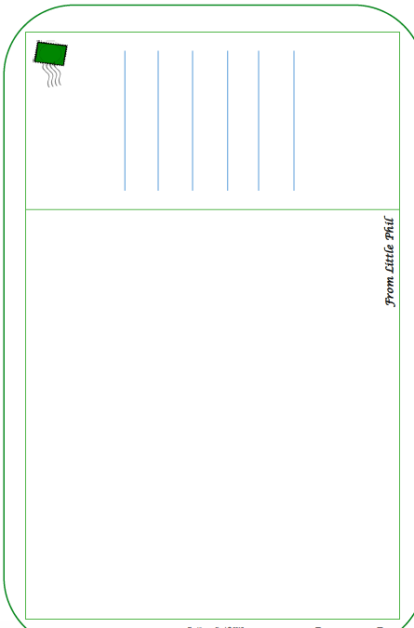
Maths: (about 20 - 30 min) Challenge!
White Rose. https://whiterosemaths.com/homelearning/year-1/
Week 10 lesson 5

Challenge questions! (ignore the date) Worksheet on the website.

Optional:
Take a mindful minute here:
https://gozen.com/a-mindful-minute-3-fun-mindfulness-exercises-for-kids/ and then think of how lucky we are to live in such a beautiful place! Think about what is special to you about where we live and fill in the sheet below!

You could also check out of this video of some Spanish children on a trip to the beach!
https://www.bbc.co.uk/bitesize/topics/zpr76sg/resources/1

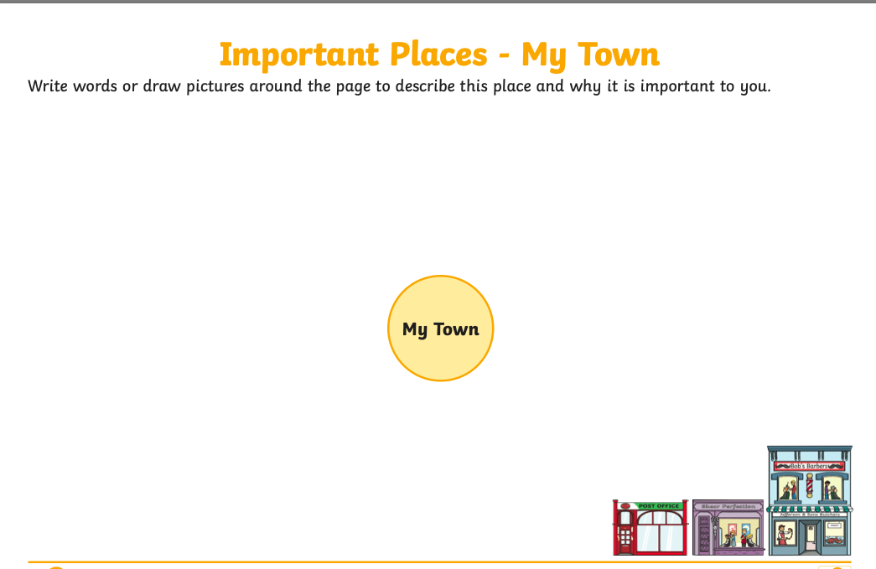

Get Moving Aim for at least half an hour of activity every day! See the resources on the Keeping Active page for ideas and try and join in with the Body Coach every morning, or go for a walk, ride your scooter or bike, jump, dance!

Happy weekend!

