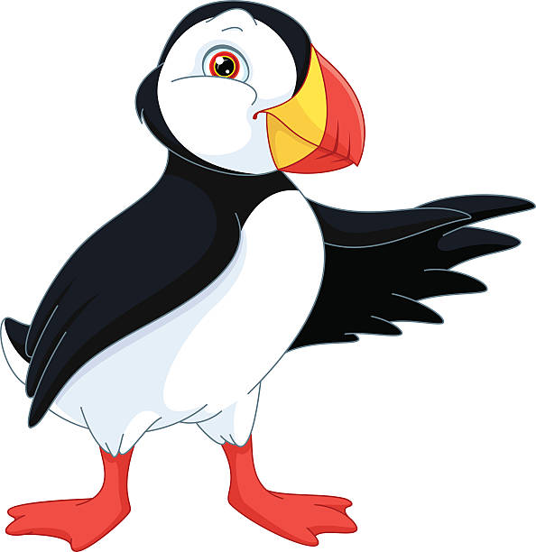
Puffins class daily schedule

Please remember to try and log in to Reflex and Spelling shed every day!

Reading: (about 10 - 20 mins)

Have a look at the Oxford Owl series - https://www.oxfordowl.co.uk/for-home/find-a-book/library-page?view=image&query=&type=book&age_group=Age+5-6&level=&level_select=&book_type=&series=#
Choose a book from here to read. You do have to register but the books should be free to read.

Continue to read for at least 10 minutes every day and talk to an adult about any words that you don’t know. Add any new words to your new vocabulary list. Check out https://alverton.eschools.co.uk/website/reading_resources/462727 for lots of ideas!

Or borrow a book from school - you can phone reception to make an appointment and come in to borrow a reading book from us.

Or see the resources here - https://alverton.eschools.co.uk/website/reading_resources/462727

Phonics & Spelling: (about 10 min)

This is the website we will be using: Phonics play Login: march20 Password: home

This is the website we will be using: Phonics play Login: march20 Password: home
https://www.phonicsplay.co.uk/resources/phase/5

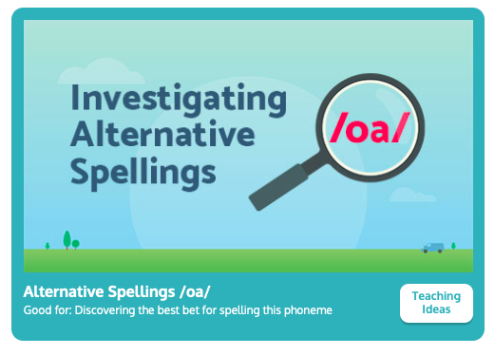
We will be practising alternative spellings this week, oa today.

Handwriting
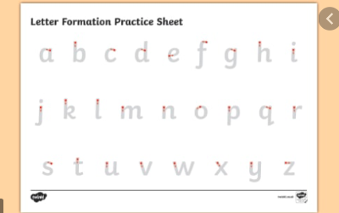
Make sure anything you write is correctly formed. There needs to be a difference between the heights of the letters.

English: (about 20 - 30 min)

Today we are going to practise writing expend noun phrases which will help us write our character description tomorrow.

Talk about the different parts of the sentences.
Things to think about: why add two adjectives?
How does it help the reader?

You can use these adjectives to help you write your expanded noun phrases.
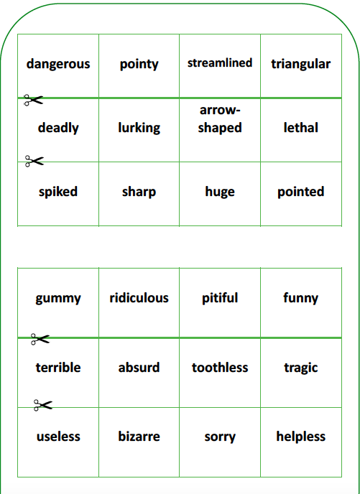
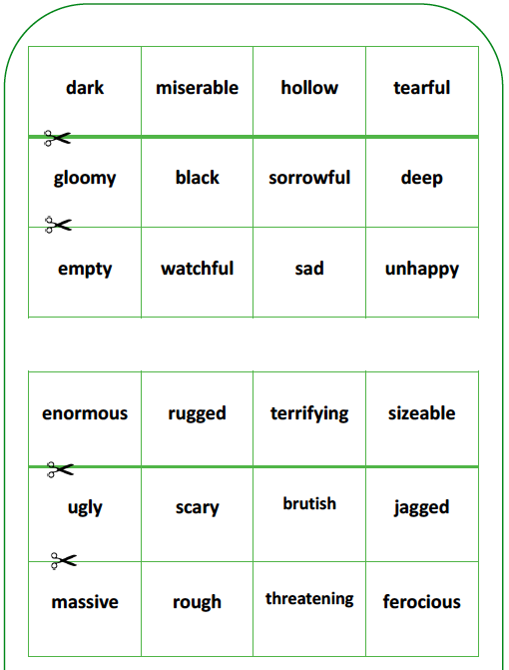

Maths: (about 20 - 30 min) counting coins

White Rose. https://whiterosemaths.com/homelearning/year-1/
Week 10 lesson 4.

For the worksheets for this weeks lessons see the link on Today’s news page.

Optional:
Use recycled materials from your home to create a sea creature! There are some examples below - what will you choose to make? Don’t forget to send a picture!

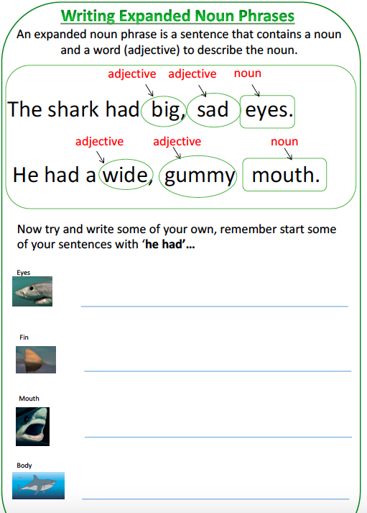
Bonus challenge: can you make a creature that actually floats in water?

Get Moving Aim for at least half an hour of activity every day! See the resources on the Keeping Active page for ideas and try and join in with the Body Coach every morning, or go for a walk, ride your scooter or bike, jump, dance!

